**The Open Container Initiative (OCI)**

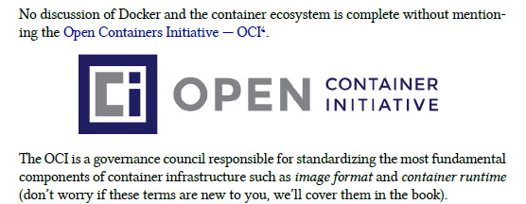

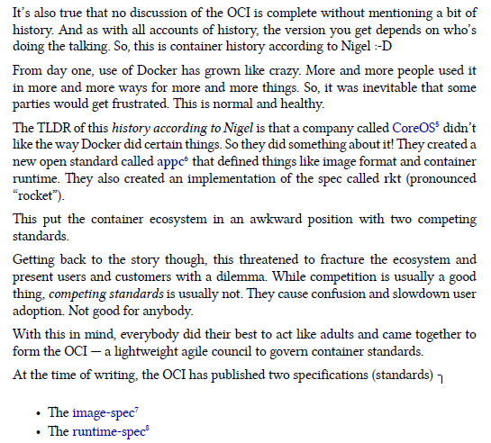

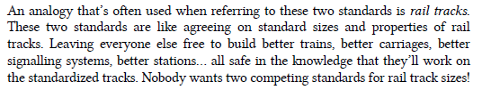

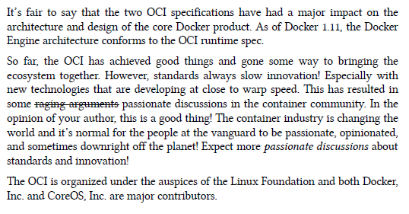

<https://github.com/opencontainers/image-spec/blob/master/spec.md>

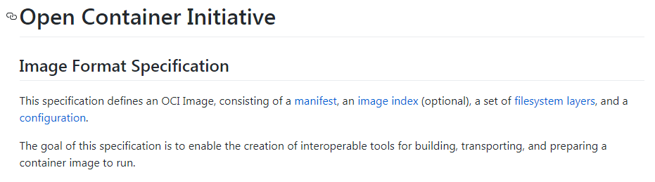

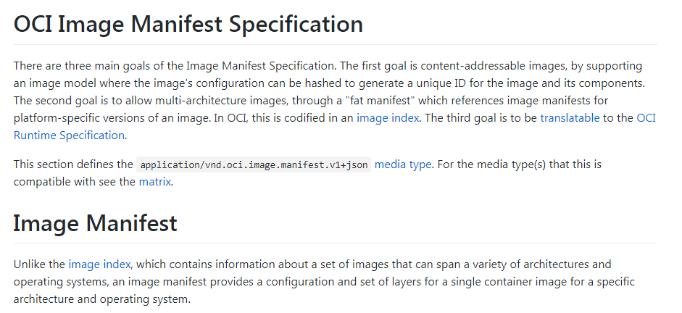

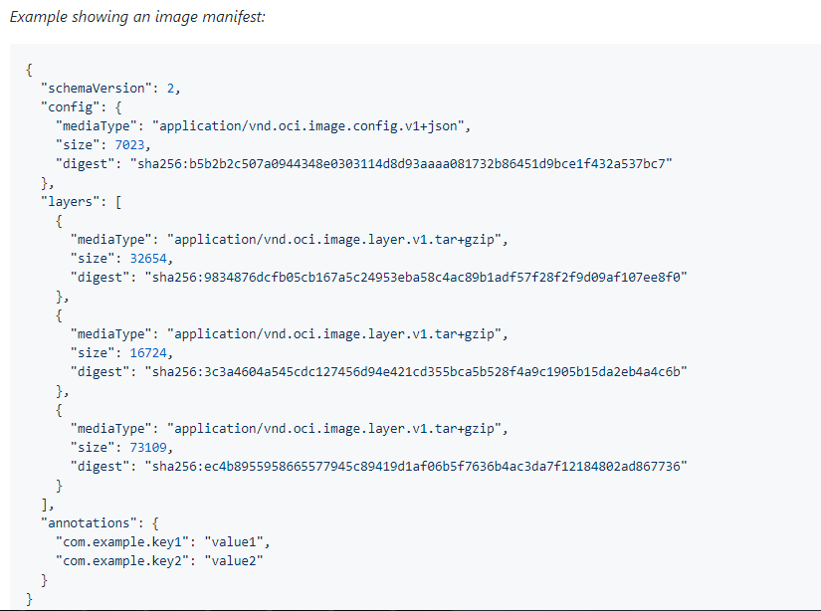

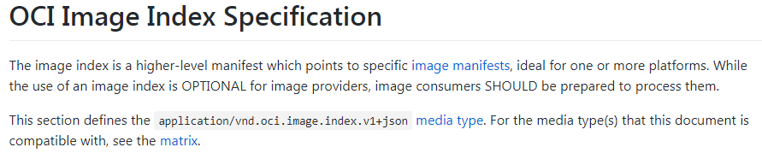

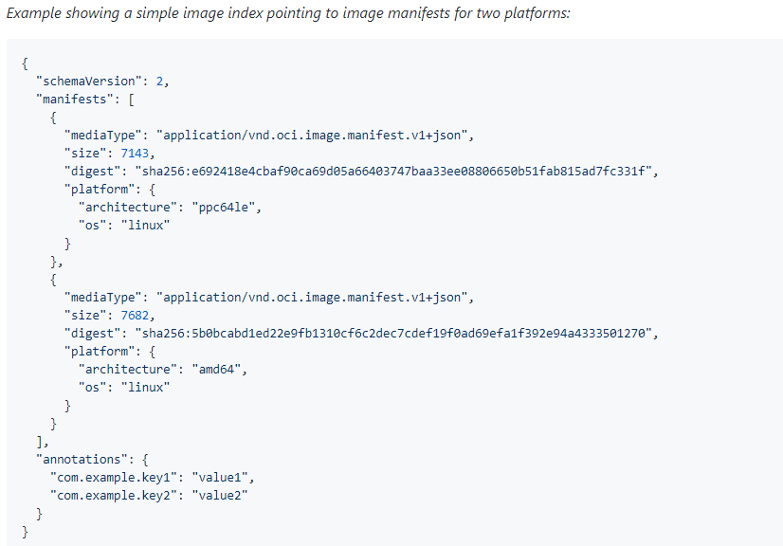

<https://github.com/opencontainers/image-spec/blob/master/manifest.md>

<https://github.com/opencontainers/image-spec/blob/master/image-index.md>

<https://github.com/opencontainers/image-spec/blob/master/layer.md>

Go through the above links

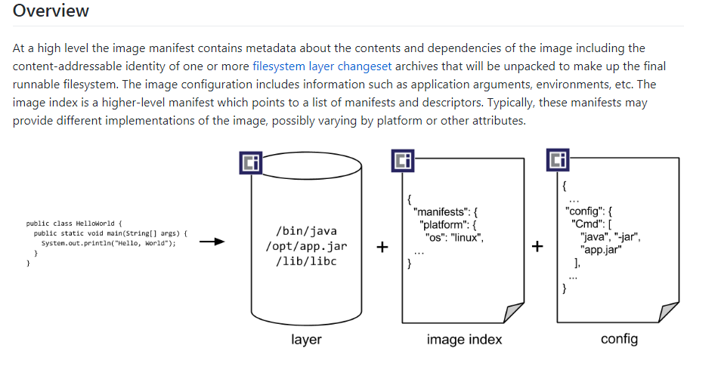

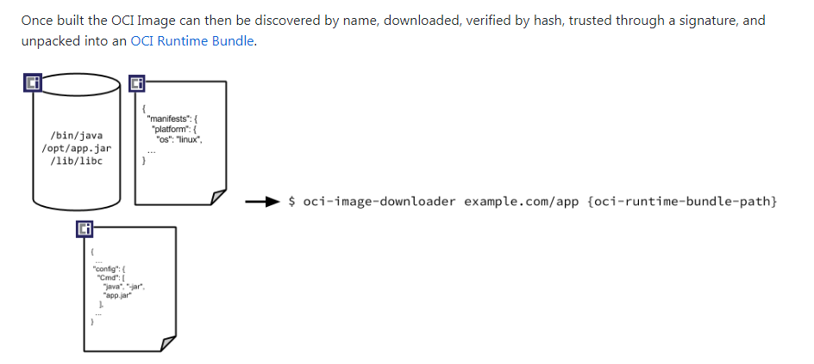

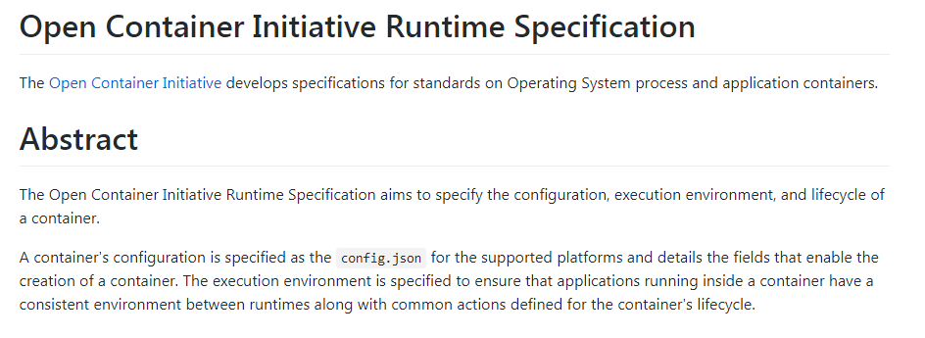

<https://github.com/opencontainers/runtime-spec/blob/master/runtime.md>

Above link should be visited if needed